
UnrealEd Terrain brush manipulation.

A quick recap.  The processes we have been though to get to this point...  We planned our terrain, made a bitmap for terraedit to import, the bitmap process works on the height field principal each pixel at its (x,y) location has a height denoted by its palette location, the pixel, for example at (0,0) within the bitmap has the colour of palette index 15 whatever colour that happens to be, so for terraedit this maps to location (0,0) on our terrain mesh will a height of 15 terraedit scale units.  So when you read though the whole bitmaps structure row by row, column by column each pixel has a palette index number, so a pixel at (row,column) = PaletteIndex, all of this information gets transposed on to the terraedit grid, for each cell (row,column) gets its height from the palette index number.  We then exported the t3d file from TerraEdit and inported into UnrealEd.  Unnecessary polygon removal.  With the level loaded into UnrealEd which contains out terrain brush.  The first image shows that there are rather a lot of square polygons, they are all at the same level and are touching each other, all of these we can get rid of, reducing that all important poly count.  To remove them we need to make some rectangular brushes of the correct size and position them under and touching the areas we wish to improve. see the second image... I have made an active (red) brush the correct size and shape and positioned it correctly, Oh I believe if you change the 3D view to use the map perspective view this helps.  See the hand showing the all important pivot point (red cross) which shows that it is correctly placed.  With the active brush in place add it, go around the whole terrain brush finding all groups of flat square polygons which are touching and at the same level, make a new brush to fit that area, place it so it is touching the terrain brush just underneath and add.  After you have found them all rebuild the level and incrememtally save the level.  Having located all the adjacent same height square polys and placed a added brush underneath, we can now do the rather scary process of coping the terrain brush to the active brush, delete the blue added terrain brush we just copied, rebuild the level again.  The third image shows all the brushes which were added which when de-intesected the now active terrain brush again them will remove the unwanted square polygons, reducing many polygons to one in some cases per group.  After the de-intersection process is complete would will notice that all groups of square polygons have indeed been reduced to one, even the long rectangled which made up the sides of the terrain brush have been reduced.  You will still notice that all brushes built intially with TerraEdit have rather a lot of flat adjacent polygons at the sides of your brush, whether or bot these will effect the viewable poly count greatly depends on the brushes geometry itself.  Any side ones below your terrain are inconsequential and if you intend on inverting the whole brush later into a subtractable brush these will disappear.  It is very difficuly to cover within this text an example for polygon removal for every case of terrain geometry, as there are rather a lot of different ways of approaching it. You may want a SUBTRACTED cube with your terrain as an ADD for your inital level starting point or just a SUBTRACTED terrain. I have tried both HillBase is the former, Terrain is the later.  I believe how you construct or manipulate the walls of your terrain is important, but this depends rather a lot on the terrain itself, it may be a terrain where the gaming arena is within valleys so the main brush walls would never been seen, or maybe the whole terrain is a hill in the middle, where the gaming arena is on the flat stepped plateaus around the hill on different levels with adjoining slopes or trenches, or a mixture of both, I believe the permuatations are endless... | 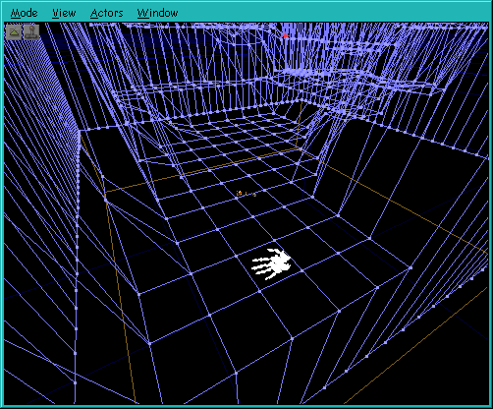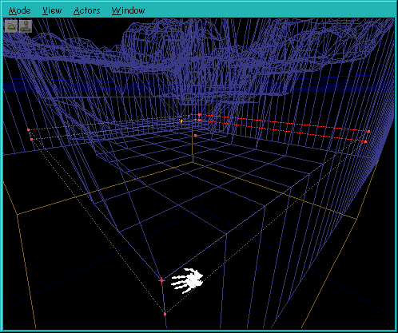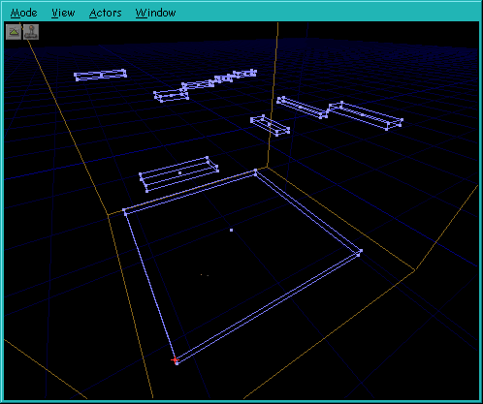

Applied polygon removel.
The images below show some more examples of where I have placed ADDed brushes so when the active brush is de-intersected with them it effectivly forces the many polygon to become one polygon, this method can be applied doing many other types of UnrealEd brush work, even adding polygons or a single polygon or single vertex or multiple vertices for applying different textures to a flat surface.
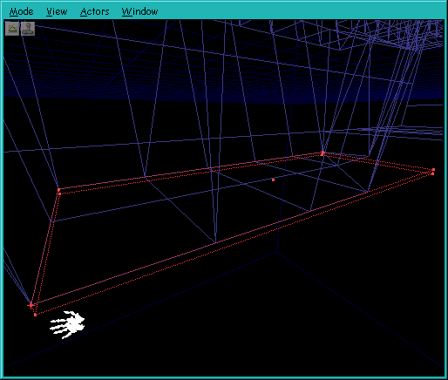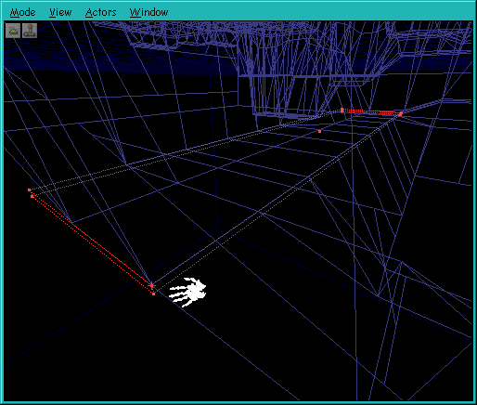
The image below is a screen shoot of an active brush with all the ADDed brushes in place ready for the de-intersect button to be pressed.
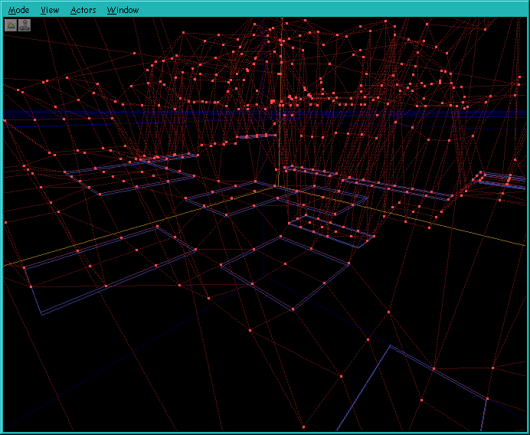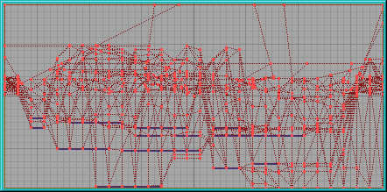

The image below shows the resultant active after de-intersection, you can see where many polygons have be replaced by one.
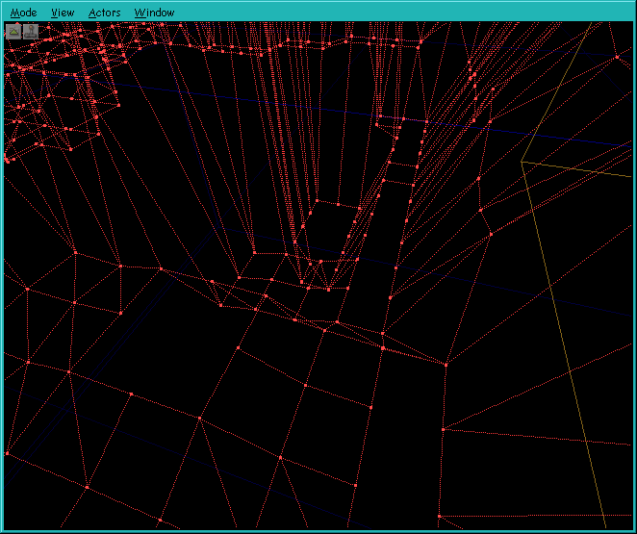

Pros and Cons of polygon removal... Important Info.
For obvious reasons, polygon removal is to keep that all important viewable polycount down to an acceptable level for what ever spec equipment you intend people to play your level on, for me depending on any planned extra geometry in various areas, like buildings, bridges, meshes and other eye candy etc etc, you have to take all of that into account as well.
I reckon on a 120 max for the terrain itself maybe more, sadly trial and error helps, but of course a very detailed plan is the way to go.
But please take my advise keep it as low as you can for playablity, good texturing and lightings can add so much and if done well, it can make a low poly terrain look very complex, so texture and light make up for any lack of complex terrain.
So high polycount complex terrains which you can't even stand on or play on, is IMHO completly pointless.
Another very good reason for polygon removal from your terrain brush, and I specifically mean any of those flat adjoining polygons here, less to texture and also for how dynamic lightly falls on these polygons.
I have found that when an actor which emits dynamic light travels over many flat polygons it just doesn't look right rather like a patchwork quilt being light panel by panel not good, with them all as one polygon this doesn't happen.
A good reason for leaving a few strips here and there is that they make good roads or runways etc etc, for what may seem obvious but would need specific textures.

